## **Log file:** [**https://drive.google.com/file/d/1kUP1ec0Jl1S9AVH2hHK1eVCZoXIeZ5sF/view**](https://drive.google.com/file/d/1kUP1ec0Jl1S9AVH2hHK1eVCZoXIeZ5sF/view)

## 

## **PUBG Esports Tournament Match API – Live Scoreboard Requirements**

### **1. Match Identification**

Every match has a **unique GameID**.  
 Example:  
  
  
GameID: '2860125895587084697'

* The PUBG API log records updates every few seconds and includes:  
  + TotalPlayerList (player-level data)
  + TeamInfoList (team-level data)
  + The current GameID
* When the GameID changes, it means a **new match** has started.
* When a match ends (last appearance of its GameID), capture its final data to calculate **total kills for teams and players** for that match.

### **2. Team Data (TeamInfoList)**

Each team entry contains:

* **Team Kills** (killNum)
* **Team Name** (teamName)
* **Team Logo** (URL or path)  
  + If missing, use a default logo: teamlogo.png from the same folder.

### **3. Player Data (TotalPlayerList)**

Each player entry contains:

* **Unique Player ID** (uId)
* **Player Name** (playerName)
* **Player Photo**
  + If missing, use a default: playerlogo.png from the same folder.
* **Kills** (killNum)
* **Damage** (damage)
* **Knockouts** (knockouts)
* **Health** (health)

### **4. Placement Points System**

Placement is determined using liveMemberNum from TeamInfoList:

* When a team’s liveMemberNum becomes 0, that team is eliminated.
* Teams are ranked **from last eliminated to last surviving**.

**Placement Points Table**:

| **Position** | **Points** |
| --- | --- |
| 1 | 10 |
| 2 | 6 |
| 3 | 5 |
| 4 | 4 |
| 5 | 3 |
| 6 | 2 |
| 7–8 | 1 |

Points are **added after every match** to each team’s tournament total.

### **5. Live Scoreboard Display**

The live scoreboard should update in real time and include:

* **Rank** (based on total points, then kills)
* **Team Logo** (or teamlogo.png if missing)
* **Team Name**
* **Health Bars** – one per player:  
  + Blue portion = current health %
  + White portion = missing health %
  + Example: Player with 60% health → 60% blue, 40% white.
* **Team Kills** (sum of kills by team members)
* **Total Points** (kills + placement points)

### **6. Tournament Logic**

* Multiple matches will be played.
* The scoreboard **accumulates kills and placement points** for the entire tournament.
* The display must be updated live using the API log.

**WE NEED THESE 5 overlays from log data.**

1. **Live ScoreBoard**

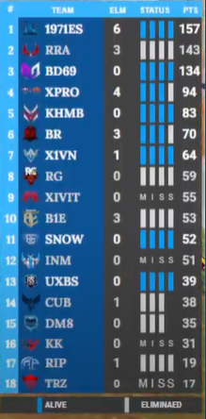

1. **Player Standings**

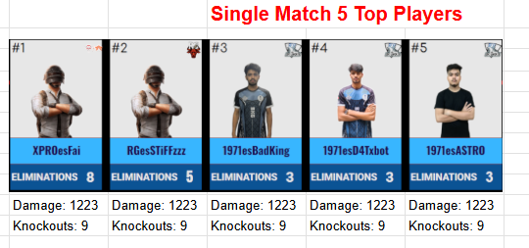

1. **overall Player Standings**

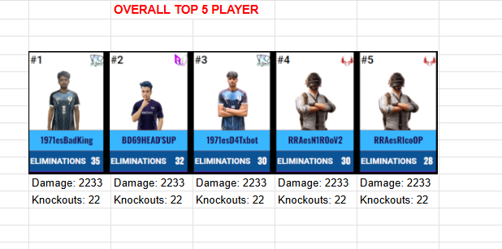

1. **Match Standings**

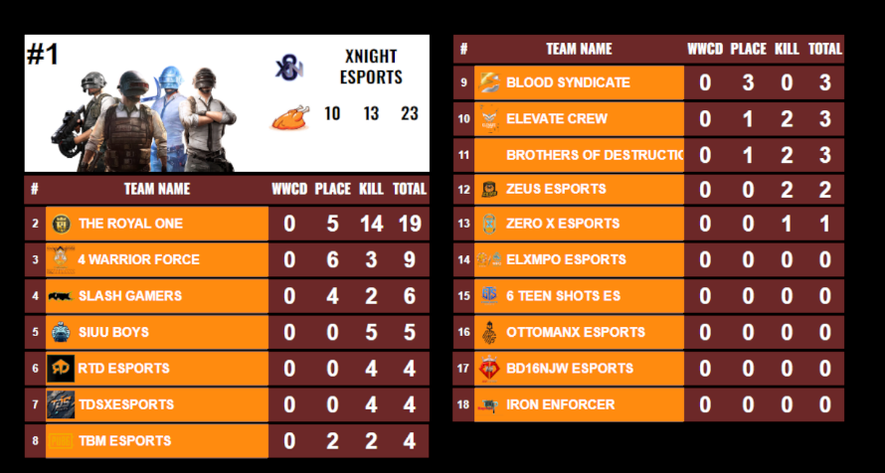

1. **Overall Match Standings**

